*BRAINSTORM*

*GYM*

***Project by team Action Code:***

***Muhammad Zain Farooq Khan 2974976***

***Farrukh Jahangeer 2960928***

***Khusmanda Ramanjooloo 2953316***

# MAIN PAGES

## HOME PAGE

The home page has a navigation bar followed by a welcoming picture and link. The page has an introduction about the gym and two features boxes of offers. The title of the feature boxes is a link to the offer page where more details can be obtained.

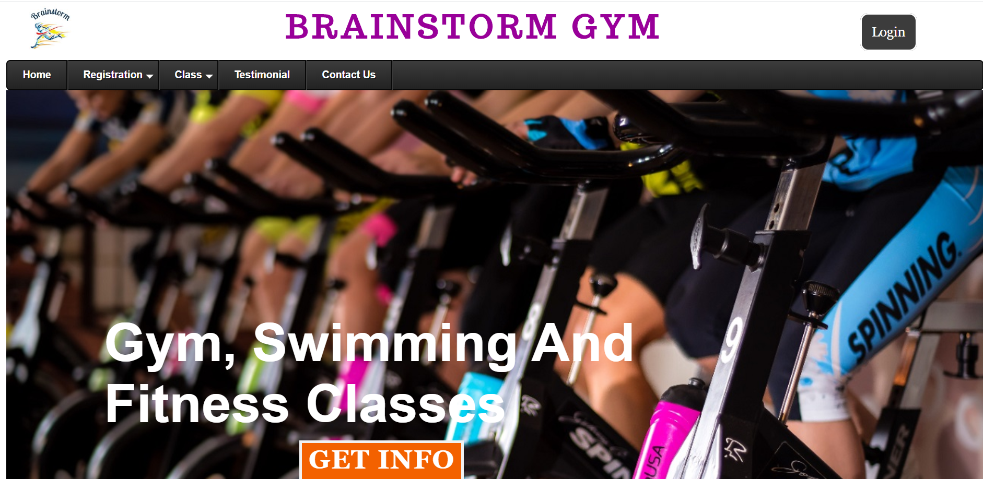

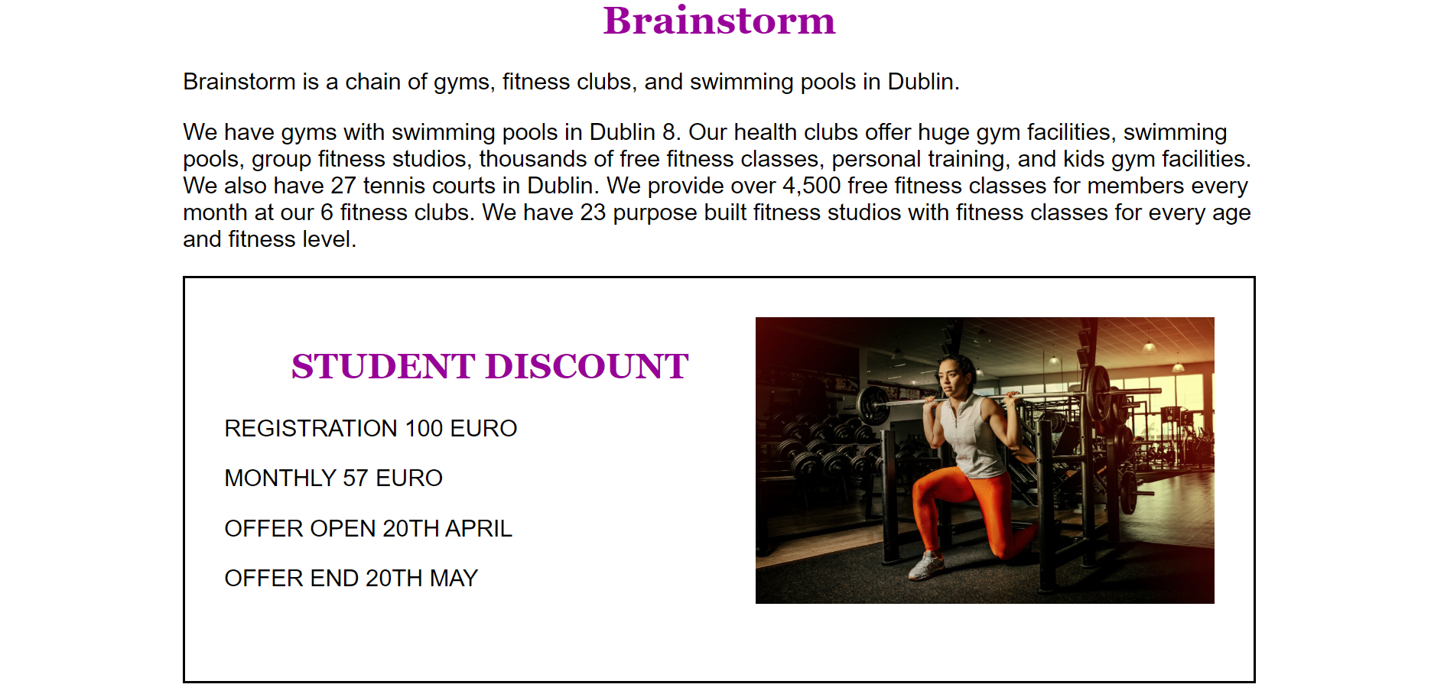

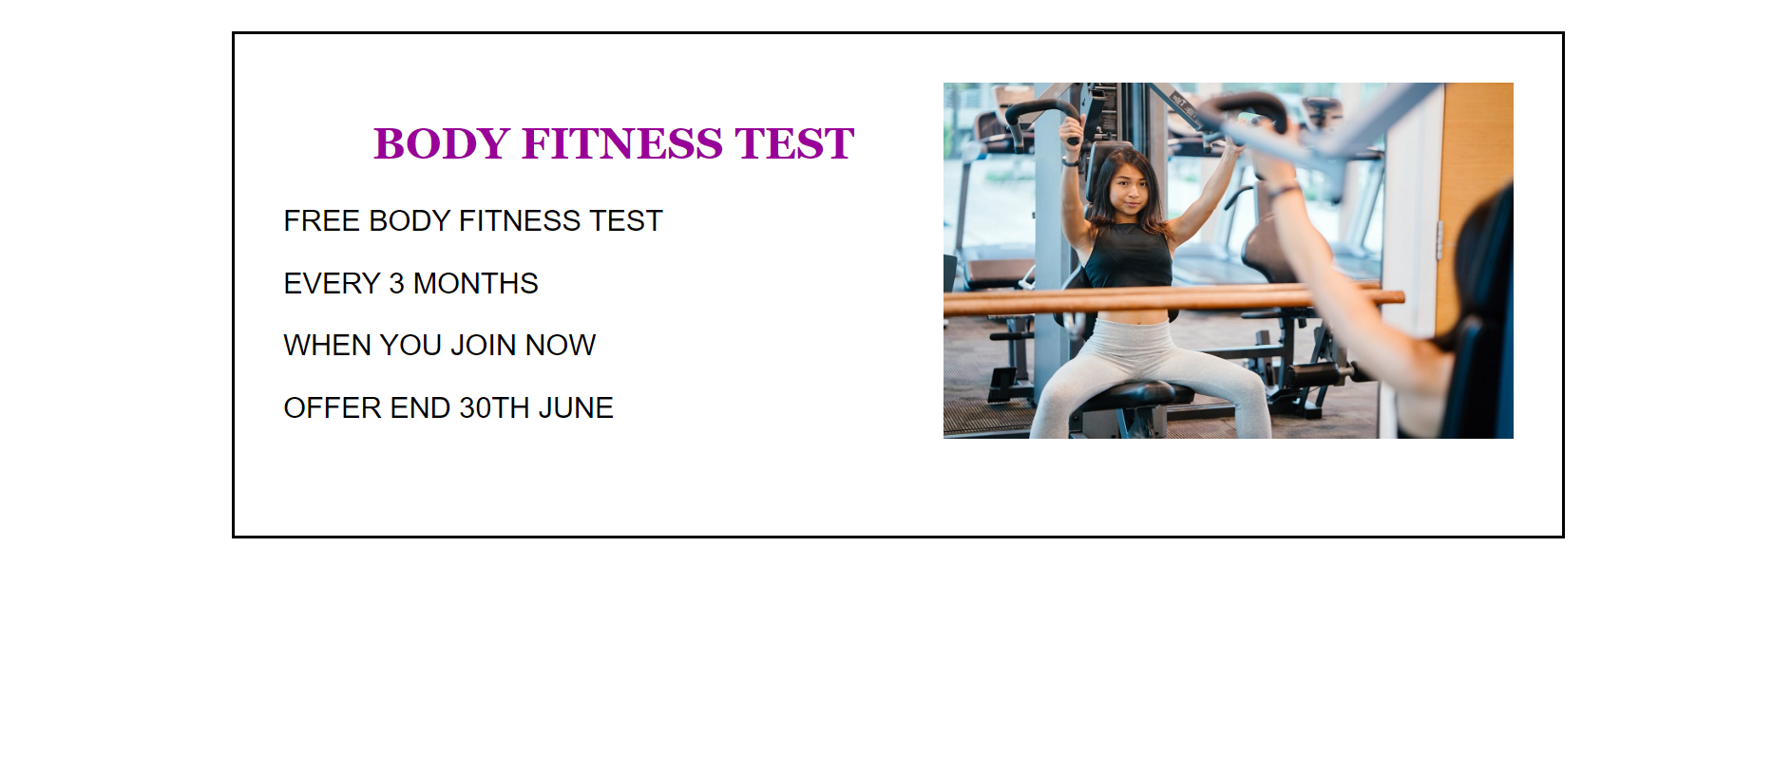

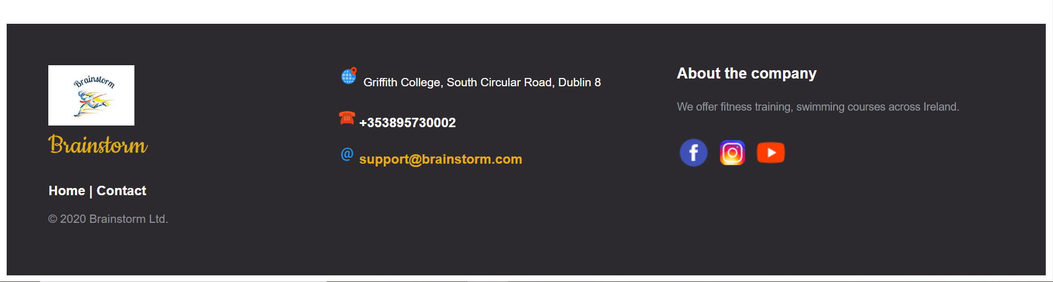

## REGISTRATION

The registration pages have details about membership, the benefit of joining this gym and the fees for each category of people. There is also a link that enable to register for a particular course.

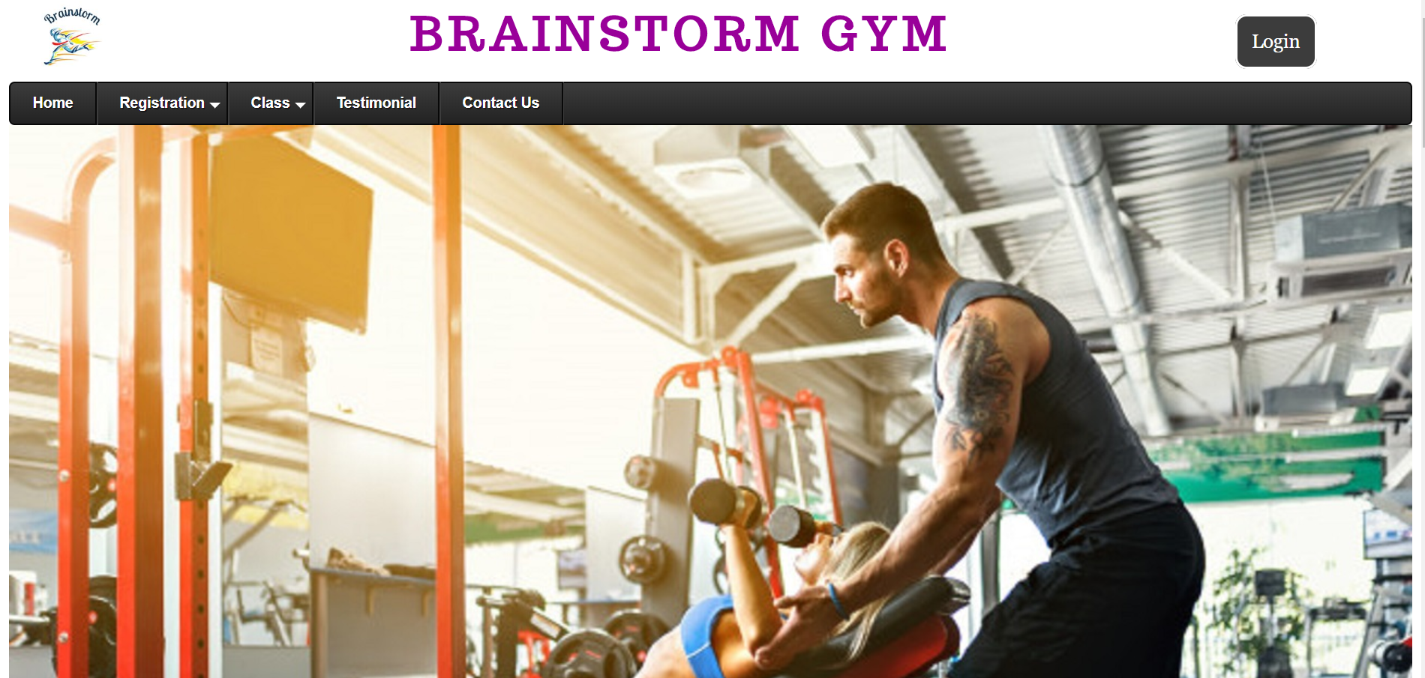

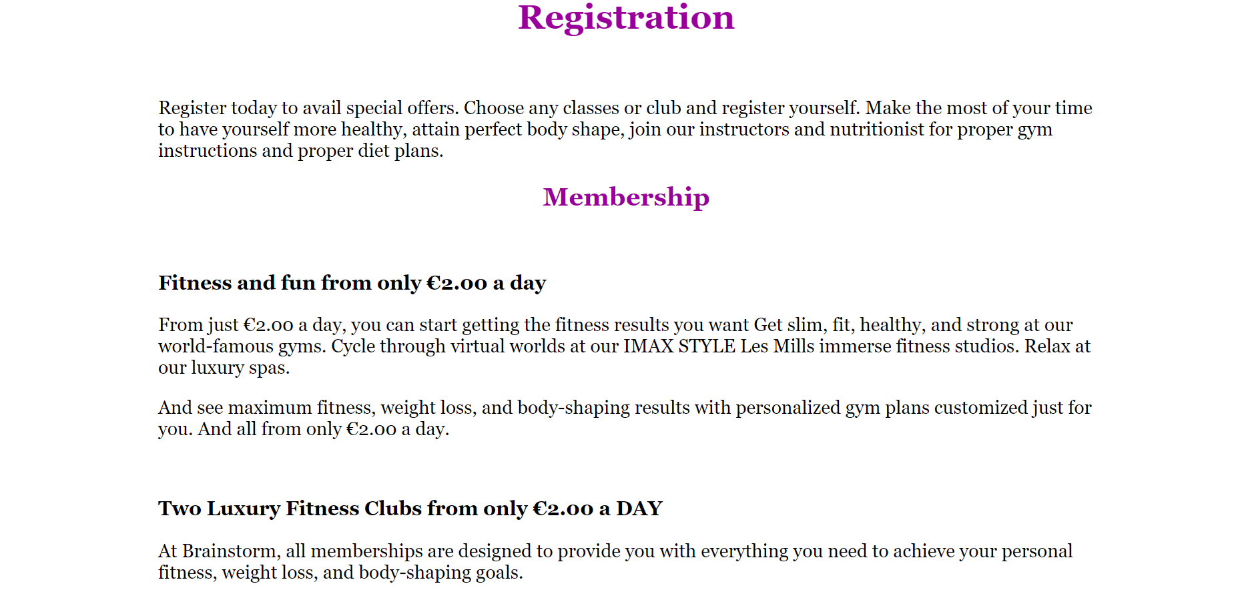

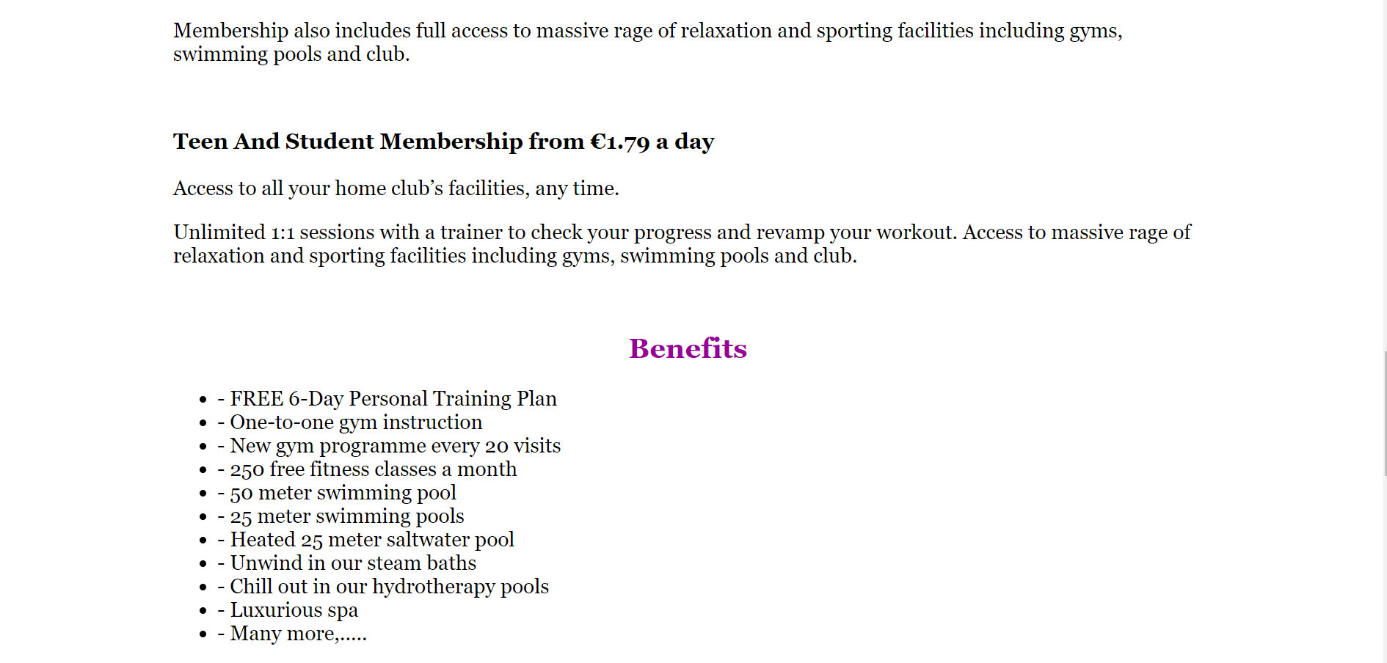

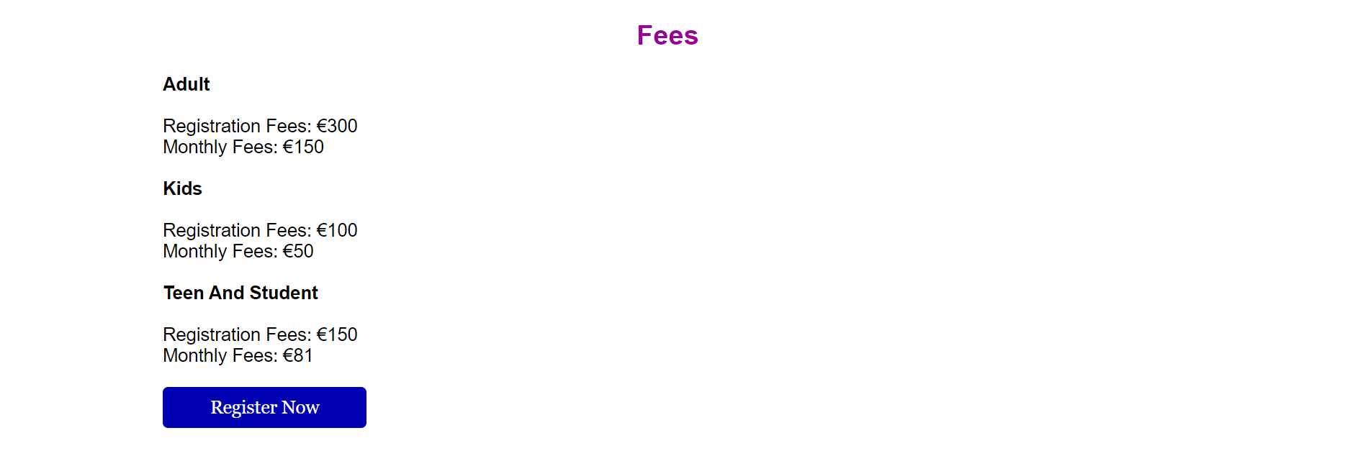



## CLASS

The class page shows a picture of some of the main classes. By clicking on the picture, it brings the member in a page with detail information about the class, if not login it brings the user to the login page.

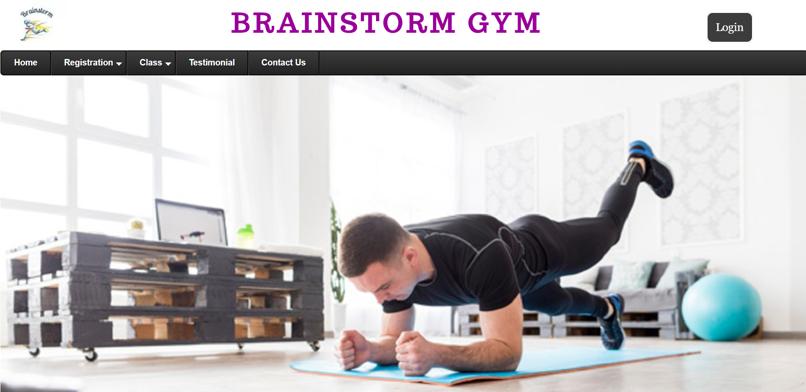

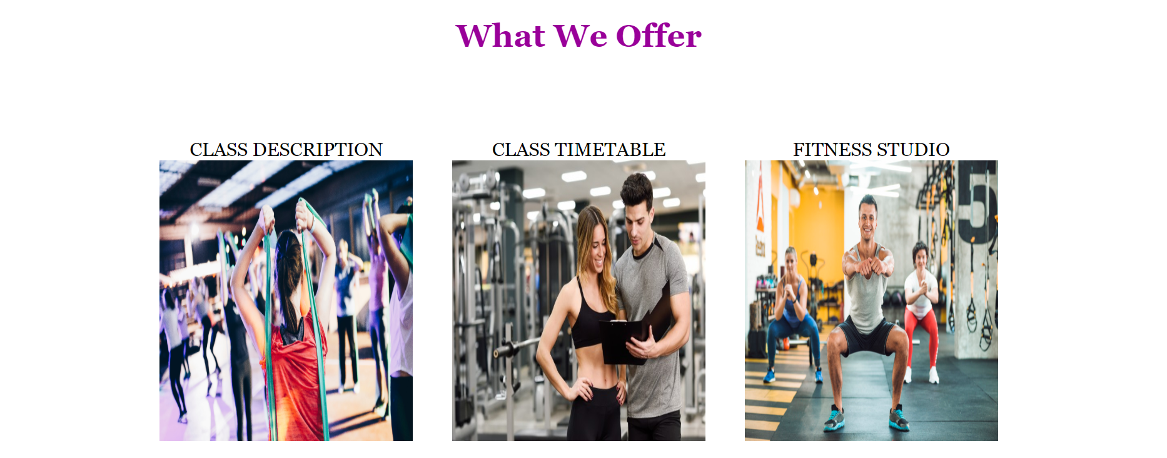

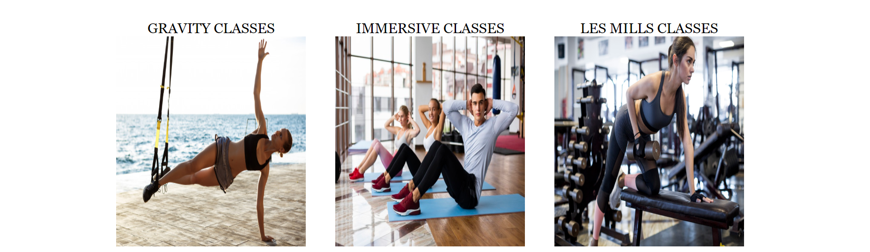

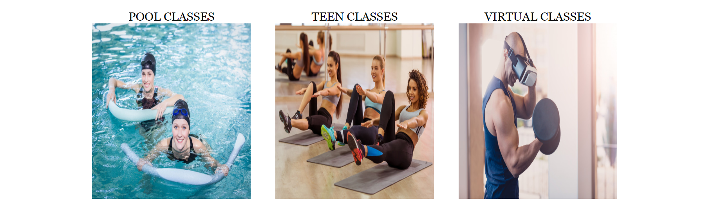



## TESTIMONIAL

Testimonial is a page that shows all approved feedback from members.

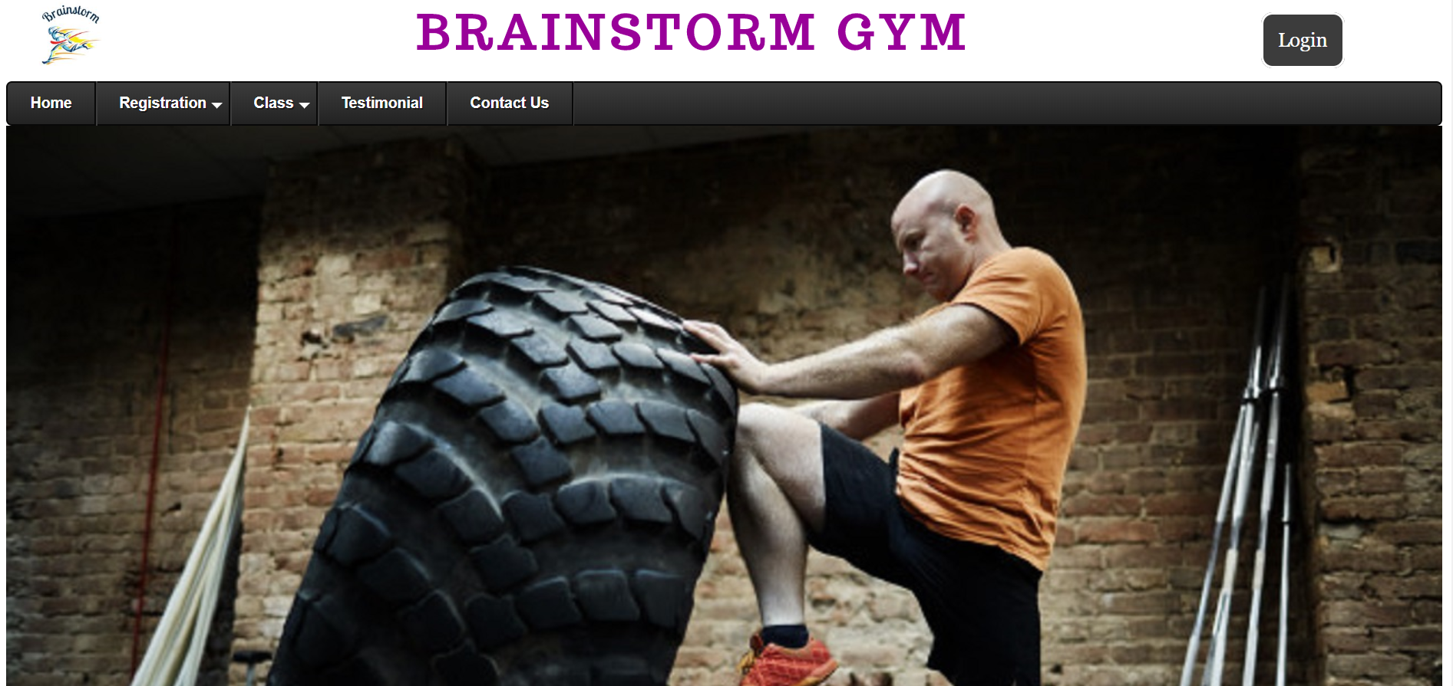

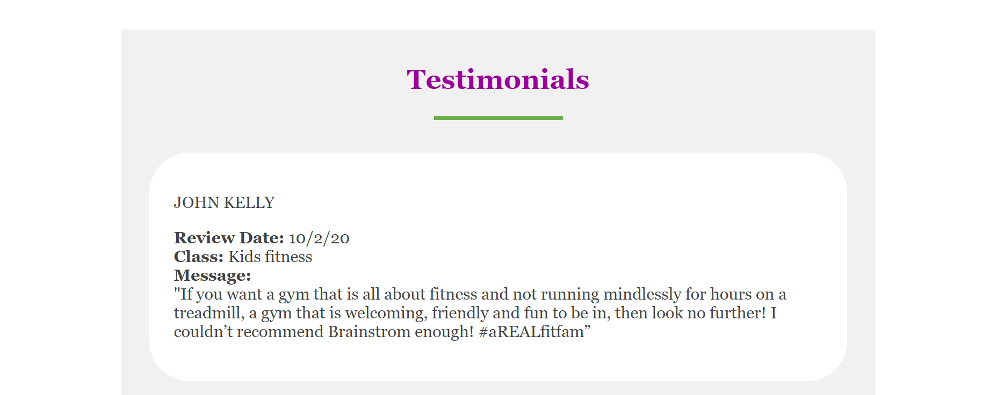

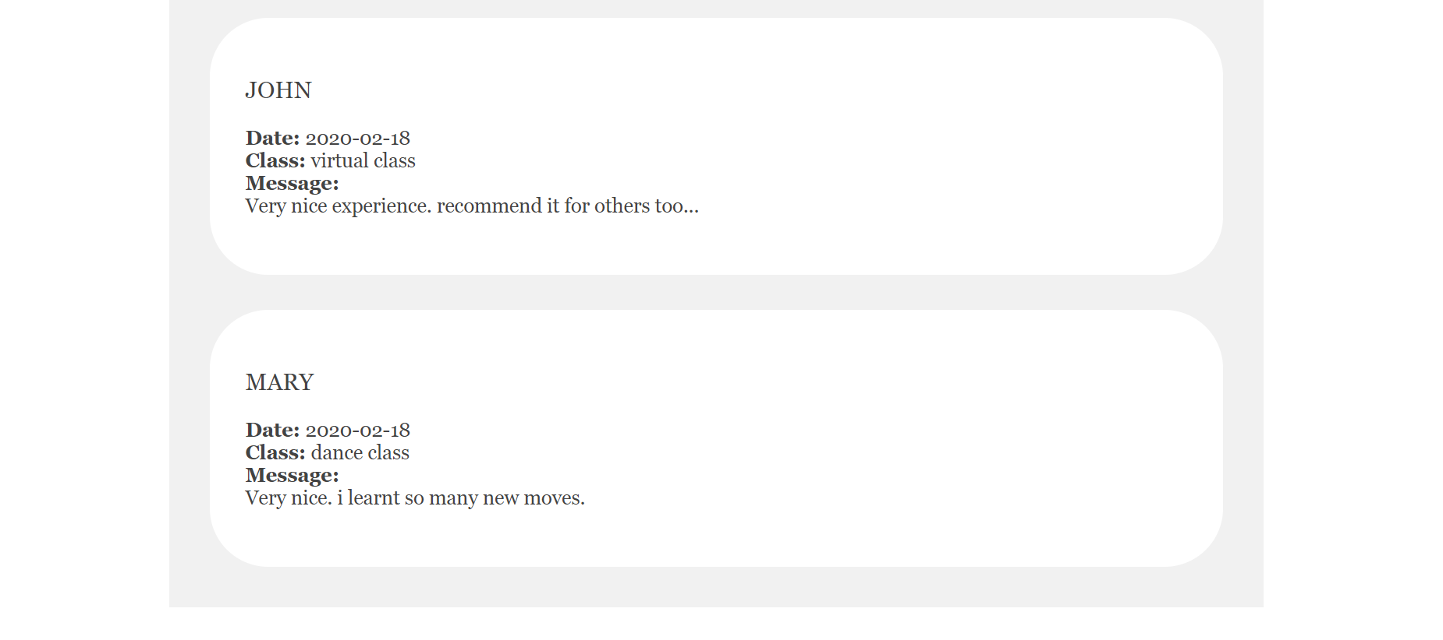

## CONTACT US

Contact us is a where a user can send the gym admin messages to ask for more information.

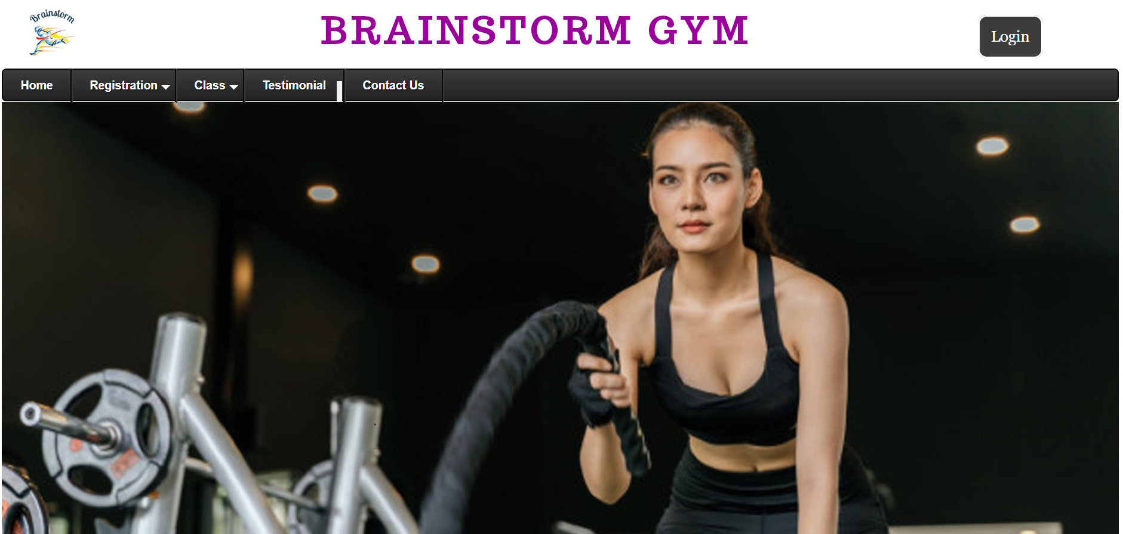

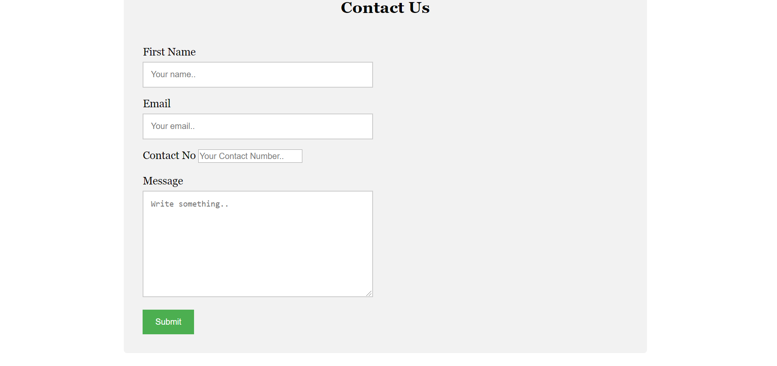



# ADDITIONAL PAGES

### MEMBER LOGIN

### 

Member login form where member must input username and password to gain access to all member pages. If someone wants to register as member, they can sign up as well.

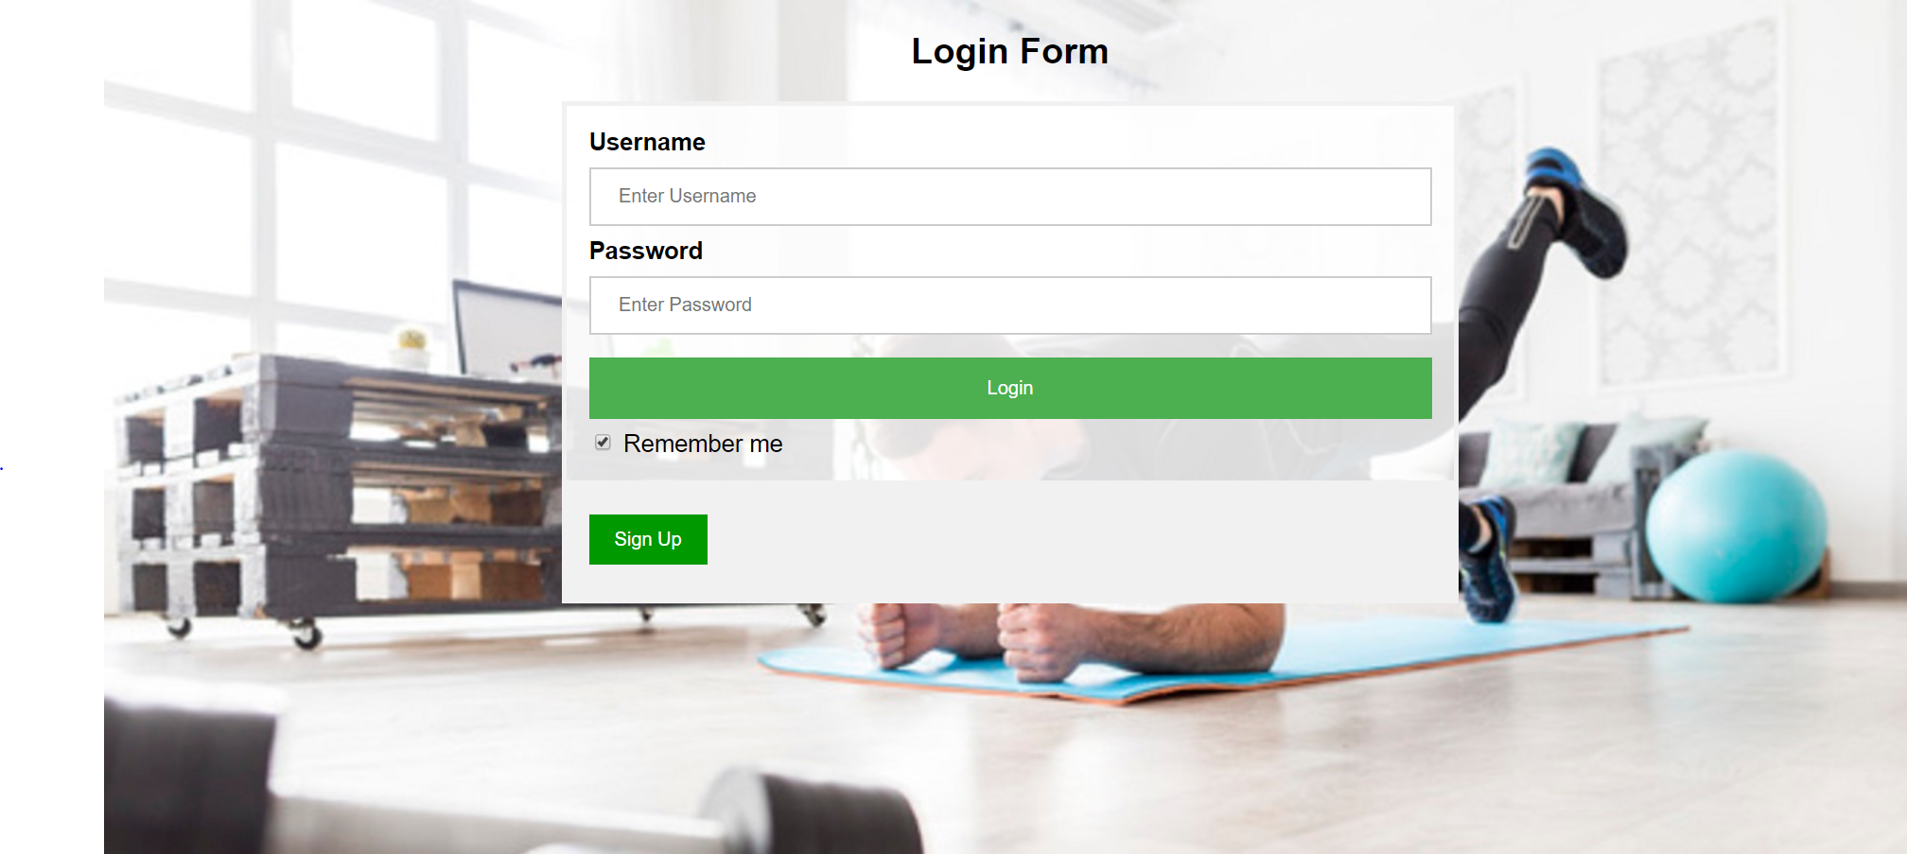

### MEMBER LOGIN NAVIGATION BAR

This is the navigation bar of a member where there are more pages that can be access than a public page.

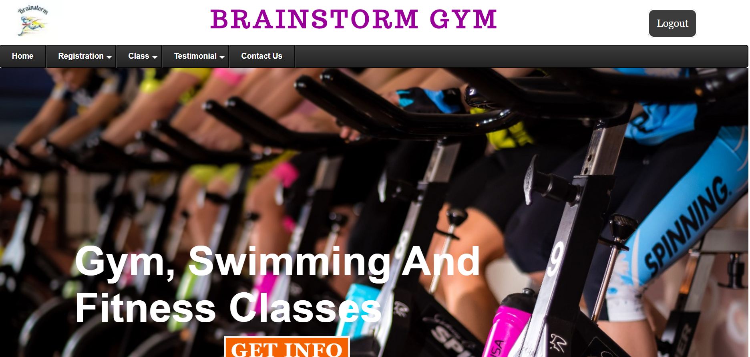

### MEMBER AND ADMIN COURSE REGISTRATION

Members can register for a course by filling this form.

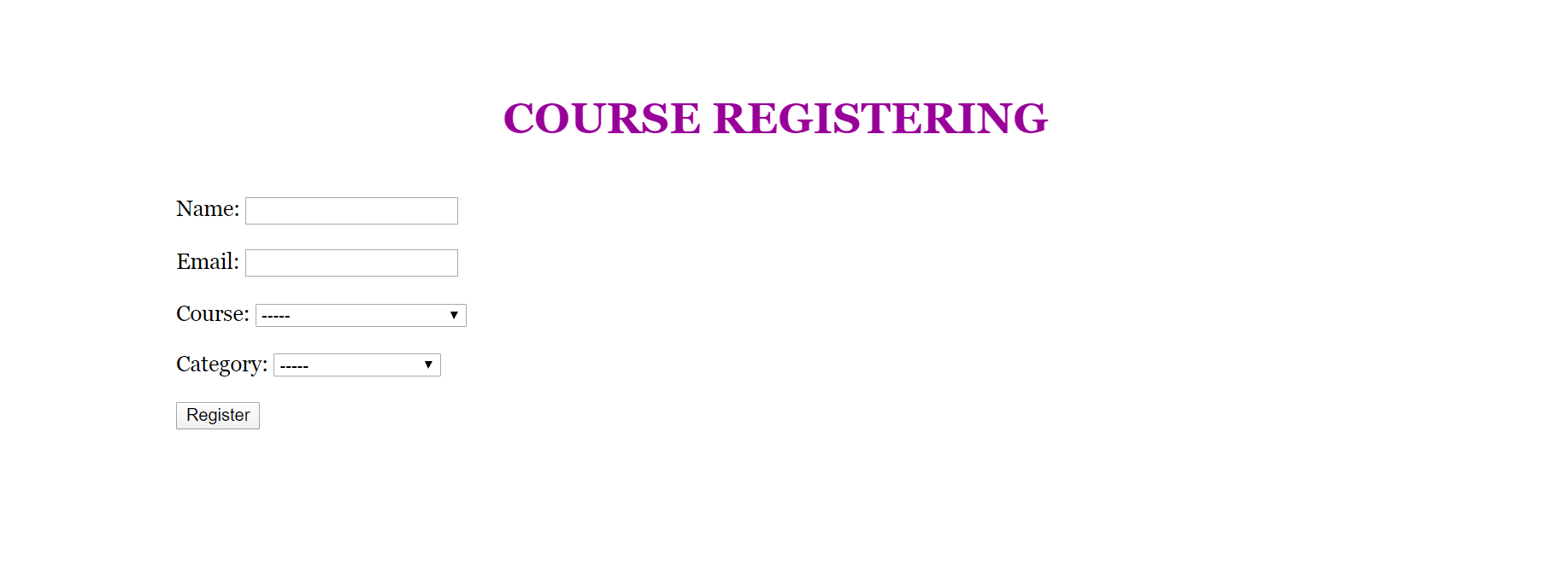

### CLASS DETAIL

Detail about a particular class. It consists of a picture, a description and a link to a timetable.

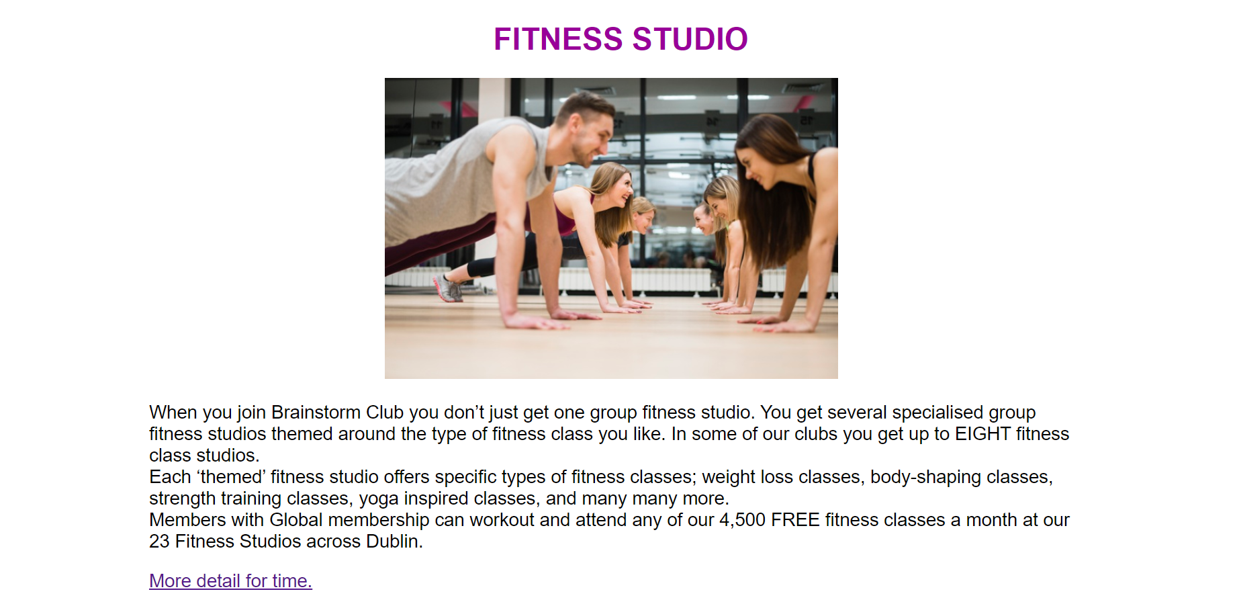

### ADDING TESTIMONIAL

Member can add their testimonial in the following page.

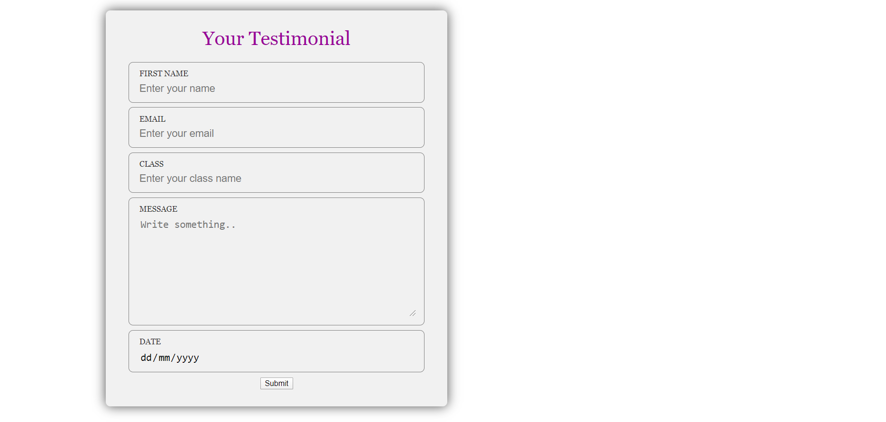

## ADMIN EDITING PAGE

Editing page show a dropdown menu where the feature that has to be changed can be selected.

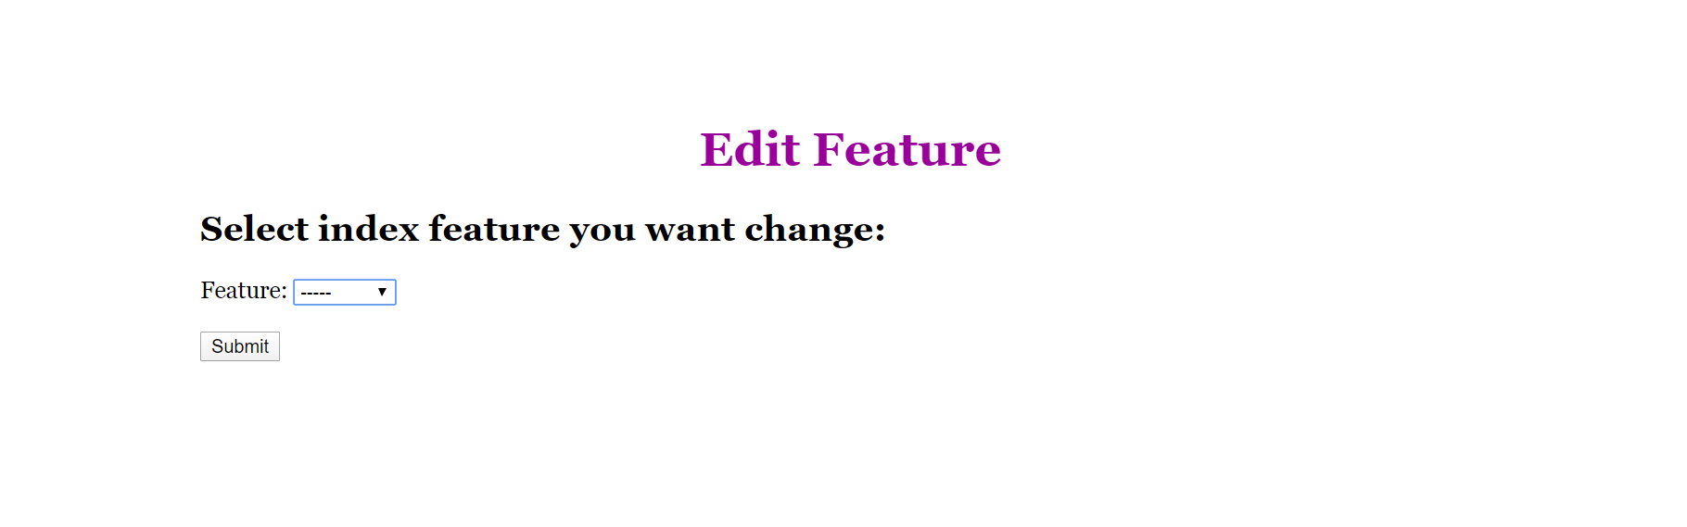

Upon selected the feature, the data is retrieved from database and is allowed to be changes.

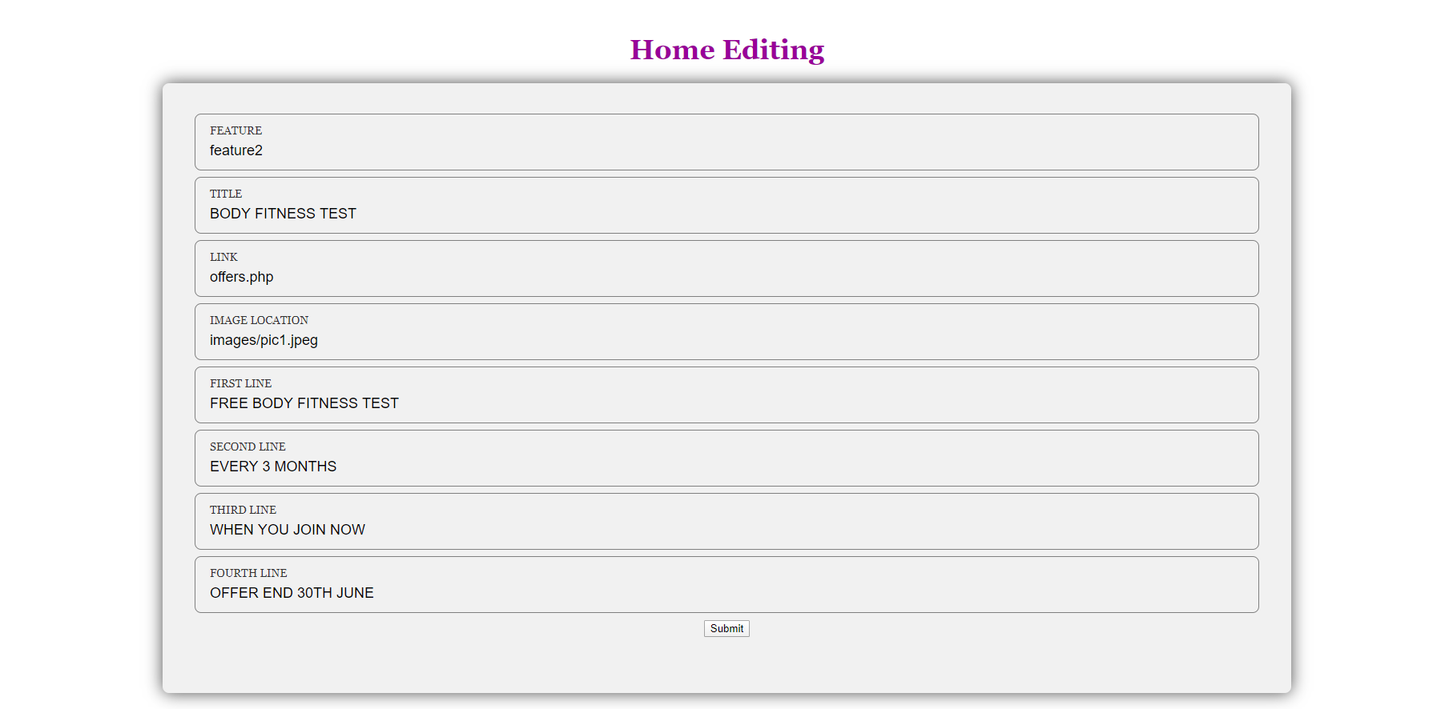

### TESTIMONIAL EDIT

The testimonial that members entered are shown here, the admin has to approve it for it to appear in testimonial page.

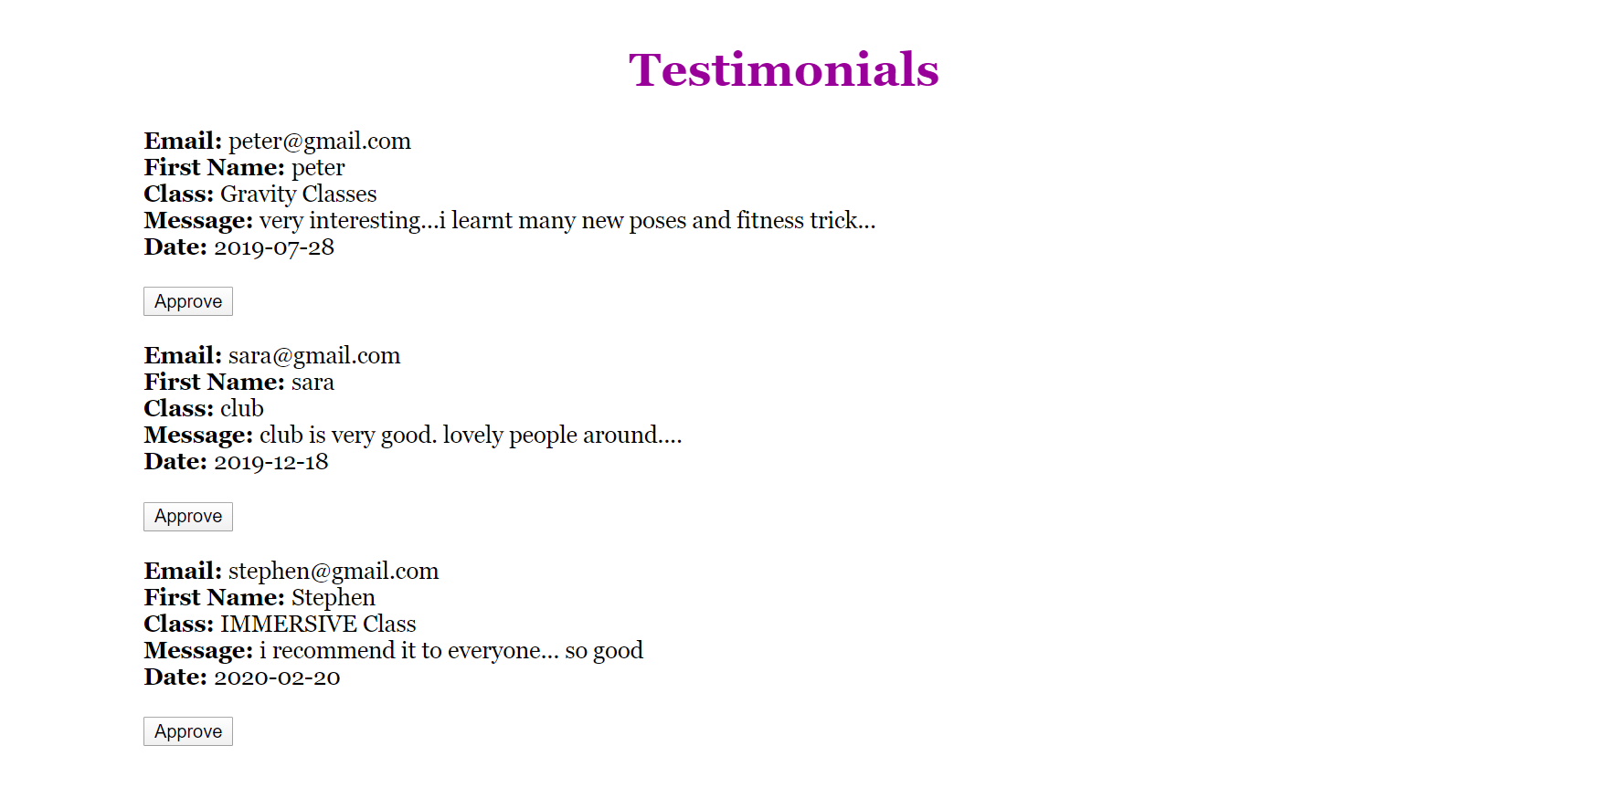

### KID’S PAGE

Kid’s page display information about kids’ classes.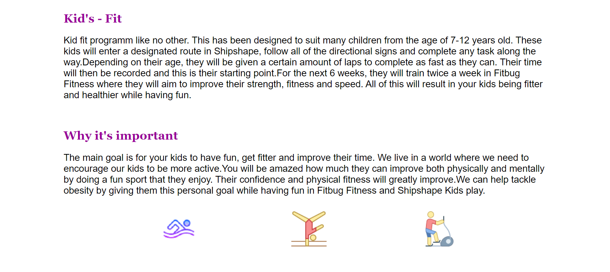

### OFFER PAGE

Offer page show the special offers that can be availed at the moment.

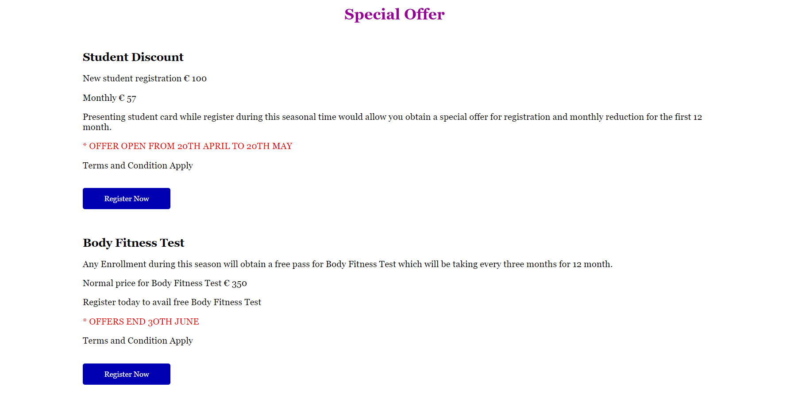

### CONTACT EDIT MANAGEMENT

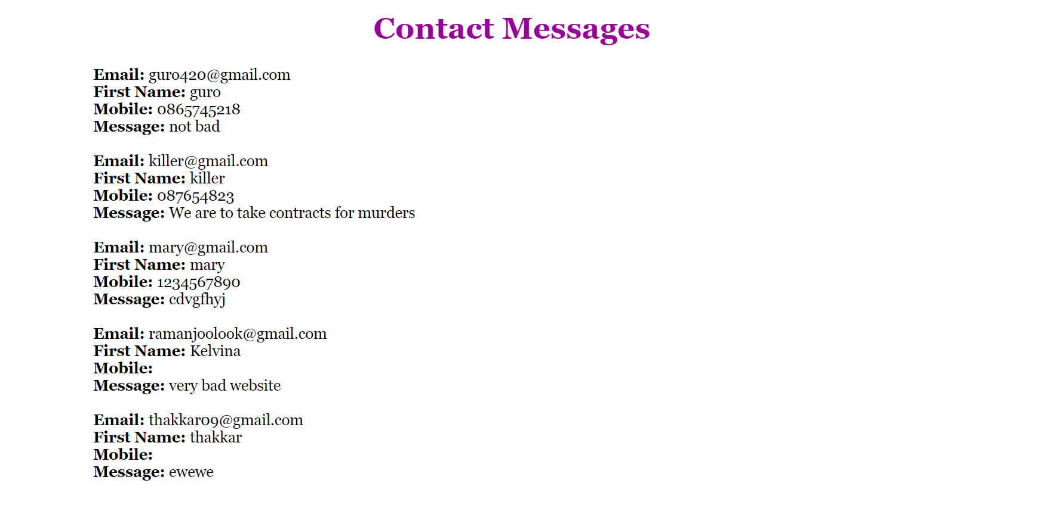TIMETABLE

The timetable gives the time slots for each session of a class.

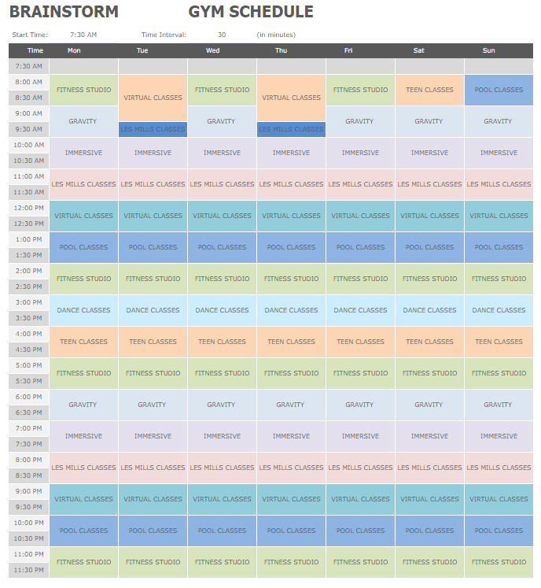

# PAGES AND THEIR FEATURES

|  |  |
| --- | --- |
| **NAME OF PAGE** | **FEATURES** |
| Home page   * index.php | * Has 2 offer features which are link for more details |
| Offer page   * offers.php | * Show detail about offers that are currently available * Link to register |
| Registration page   * registration.php | * Display information for membership and benefits * Fees information * Allow to register for specific category and class. |
| Register course page   * register_course.php | * Members can register for category and allow selection of class. |
| Class page   * class.php | * A selection of classes which are also link for more information. |
| Class description   * class_details.php | **Working:**   * Class description. * Link to timetable.   **Not working:**   * When a particular class is selected in class.php, its information of all class in this page rather than the selected one only.   **Improvement:**   * Whichever class is selected only that class description should be available to see. |
| Kids page   * kids.php | * Shows description about kid’s classes. |
| Testimonial page   * testimonial1.php | * Show testimonials of members and their classes. |
| Add testimonial   * testimonial_add.php | * Display a form that enables a member to give their feedback about their class. |
| Contact page   * contact_us.php | * Show a form to fill to get more information from admin. |
| Login page   * login2.html | * Display a form to sign in. |
| Sign up page   * signup-page.php | * Display a form for a user to sign up as a member. |
| Home edit page   * index_edit.php | * Display a drop down for selection of feature that can be updated * Retrieve all information from database * Allow changing and updating of information of the feature. |
| Registration edit page   * registration_edit.php | * Display a drop down for selection of which fee category has to be updated * Retrieve all information from database about the particular category * Allow changing and updating of information. |
| Class edit page   * class_details_edit.php | * Display a drop down of class name that can be selected to be updated * Retrieve all information from database about the particular class * Allow changing and updating of information. |
| Testimonial edit page   * testimonial_manage.php | * Display all testimonials that has not been approved * Allows testimonials to be approved |
| Contact edit page   * contact_us_manage.php | * Shows all messages that users have send |
| Logout page   * logout.php | * Logout out the user * Destroy the session * Display logout confirmation |
| Header   * header1.html | * has navigation bar with main pages and few link pages * for members that are signed in * has logout option |
| Header   * header2.html | * for public users and members that has not yet sign in * it has option to sign in |
| Header   * header3.html | * for admin that are signed in * has logout option |
| Footer   * footer.html | * Contain link to home page and contact us * Address, phone number and email address for contact * Link to social media |
| Timetable | * Show timetable for the gym |

# KNUTH DEPLOYMENT

Link 1 : <https://knuth.griffith.ie/~s2953316/project/index.php>

Link 2 : <https://knuth.griffith.ie/~s2960928/project/index.php>

### LOGIN DETAIL

**Username:** khusmanda

**Password:** k04091998

**Role:** Admin

**Username:** kelvina

**Password:** k04091998

**Role:** Member

# SET UP

* Set up is not required
* Just need to open link in browser

# ERD OF DATABASE

**member [ username**, first_name, last_name, birth_date, gender, email, mobile, address, password, member**]**

**Contact [** **email**, first_name, mobile, message**]**

**Course_register** **[** **email**, first_name, course, type**]**

**Testimonial_table** **[** **email**, name, class, message, date, status**]**

**Fees_table** **[** **title**, Rfees, Mfees**]**

**Feature [** **title**, feature, image, link, line1, line2, line3, line4**]**

**Class_table [** **title**, image, image2, link, paragraph]

# SITE MAP

This is the site map of the main pages.

The home page is link to an edit page and an offer page.

The registration page is link to membership and fees page, register for a course page and the registration edit page.

The class page is linked to the kid’s pages, class edit page and the general class.

The general class has a timetable linked to it.

The contact us page is linked to the contact page where users can send messages and is linked to contact edit page.

Login page is connected to sign up page. If a member is signed in they can access the logout page.

Header:

The pages are made up of three different type of headers.

Header 1: For members

Header 2: For public

Header 3: For admin

# DIVISION OF LABOUR

Division of work: *work was evenly divided*

|  |  |  |  |
| --- | --- | --- | --- |
| **Filename / Task** | **Student Name 1** | **Student Name 2** | **Student Name 3** |
| Database Design | 40% | 40% | 20% |
| Database implementation | 30% | 25% | 45% |
| GUI design | 40% | 30% | 30% |
| GUI implementation | 20% | 35% | 45% |
| Content design | 35% | 40% | 25% |
| Content Implementation | 30% | 40% | 30% |
| Form design | 35% | 30% | 35% |
| Form implementation | 35% | 30% | 35% |